**Medicine Label Classification API**

**REST API:**

Develop a REST API that could read specific parts of the labels on Medicines,

* MRP
* Expiry
* Batch number

This REST API is developed using Django framework and compatible for Web browser and Android.

* **Input to API :** cropped image as input
* **Output from API :** 
  + The Batch
  + The MRP
  + The EXPIRY DATE
  + Weight of the Medicine (Weight extraction support for seven segment display)

**Software used for API Development:**

| **Software/Library** | **Version** | **Description** |
| --- | --- | --- |
| Django | 3.1.2 | Django REST API development. |
| django-celery | 3.3.1 | Django Library |
| django-computed-property | 0.3.0 |  |
| django-configurations | 2.2 |  |
| django-filter | 2.4.0 |  |
| djangorestframework | 3.12.1 |  |
| Python | 3.7.7 | Language for Software Development. |
| regex | 2020.7.14 | Natural Language processing Library (Regular Expressions) |
| OpenCV | 4.4.0 | Open CV for computer vision and Image processing. |
| pytesseract | 0.3.6 | API for Word extraction from images |
| numpy | 1.19.1 | Python Library for numerical activities |

|  |  |  |
| --- | --- | --- |
| numpy | 1.19.1 | Python Library for numerical activities |
| datefinder | 0.7.1 | Python Library to extract the dates |
| datetime | Python inbuild | Python Library for date and time |
| os | Python inbuild | Python Library for path relted activities |
| pytest-shutil | 1.7.0 | Python Library for Shell utilities |
| pathlib | ?? | Python Library for file paths. |
| Matplotlib | 3.2.2 | Python Library for plotting. |
| sys | Python inbuild | Python Library for system specific paramters |

Tesseract can be built for Android as a static command-line executable tesseract, or you can use [Java binding](https://github.com/rmtheis/tess-two) to work with **libtess** from Android app. Please refer the following details:

**https://tesseract-ocr.github.io/tessdoc/Compiling.html#android**

**Instructions for better results:**

* There should not be any shadows in the image.
* Image should be with No blur and No shake
* Take image with good lighting condition
* Do not use Flash
* Take image as close to the Label (The more closer the better the accuracy).
* Images should be straight. Do not take tilted images.
* Crop the images as close to the text area (with out Licence No details)
* Weight extraction support for seven segment display

**Work Instruction to run the Demo application for the API:**

1. Go to the Project Root folder.
2. Type the Python command “python manage.py runserver”

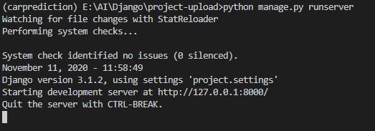

1. Once the Development server started run the application <http://127.0.0.1:8000/> using the browser. 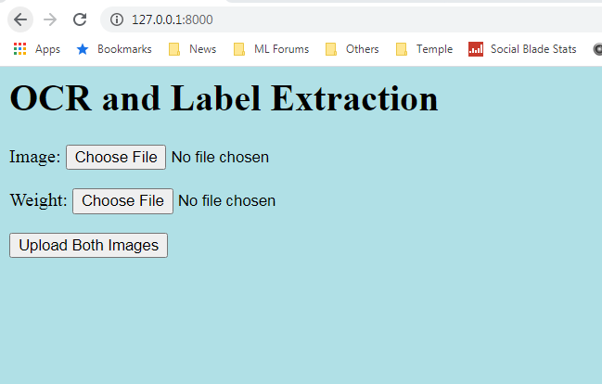
2. Fill the details and upload the image to extract the text. The following page will be redirected with Batch No,MRP ,Expiry date and weight details.

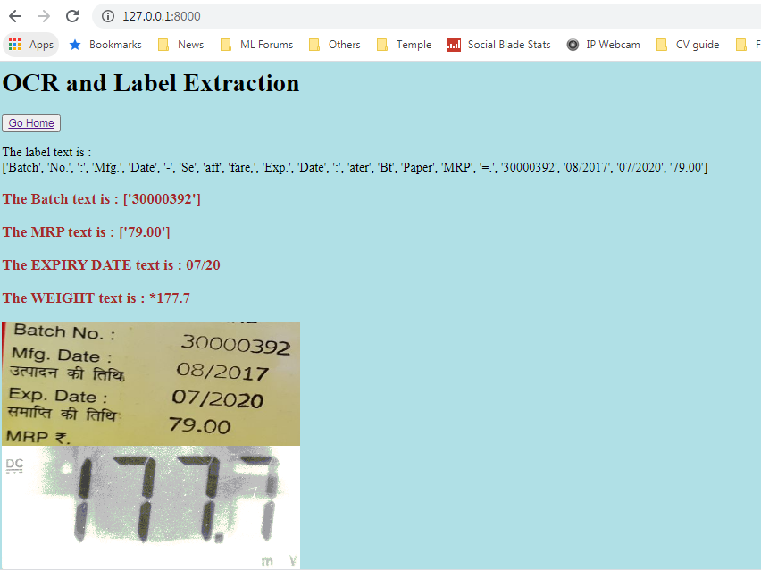

**Limitations of the API:**

* label in Bottles are misrecognized. (As the bottles in are cylindrical shape, word image get distorted).
* labels present in the tablet aluminium strip foils are misrecognized.
* Images including wide non-character space are misrecognized.Take the image to include only the space containing characters
* All characters which are not taken horizontally by a camera are misrecognized

**API software Attached:**



**Weight images and Medicine Images used for testing:**



